Non-Surgical Low Back or Neck
Spinal Decompression - Intake Form

Full Name: ____________________________________________________________________________

Date of Birth (D/M/Y): ___________________________

Please indicate your area of concern on the diagram:

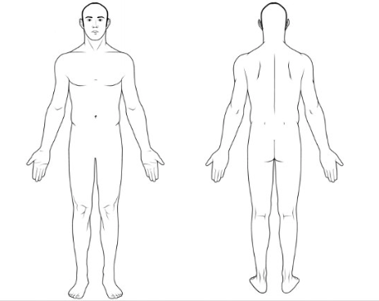

Have you had any of the following for your low back or neck?

Cortisone Shots: Y / N When?______________ Where?_______________________________________

MRI / CT Scan / X-Ray: Y / N When?______________ Where?_______________________________________

Surgeries? Y / N When?______________ Where?_______________________________________

Spinal Fractures? Y / N When?______________ Where?_______________________________________

Disc replacements or
kyphoplasty? Y / N When?______________ Where?_______________________________________

Describe the issue that made you want to seek treatment: _________________________________________________

____________________________________________________________________________________________________________________

When did this concern start? __________________________________________________________________________________

Is your pain worse in the: Please rate your pain:

MORNING / AFTERNOON / EVENING (NONE) 0 1 2 3 4 5 6 7 8 9 10 (SEVERE)

What makes the pain better? __________________________________________________________________________________

What makes the pain worse? __________________________________________________________________________________

Do you get nerve pain in your arms or legs? Y / N Where? ________________________________________________

Describe the pain: DULL / ACHY / SHARP / SHOOTING / TINGLING / NUMB / OTHER:__________________

What other practitioners have you seen for this issue?

____________________________________________________________________________________________________________________

Please list ALL medications you take and the condition you take them for:

____________________________________________________________________________________________________________________

____________________________________________________________________________________________________________________

Please note, that the following MAY be a contra-indication to spinal decompression treatment:

- Failed back surgery • Spinal Fusion
- Acute Disc Bulge or Herniation ( Less than 4 weeks)

Please note that the following ARE contra-indications to spinal decompression treatment:

• Pregnancy (low back) • Severe Osteoporosis • Artificial discs
• Moderate to severe spondylolisthesis • Spinal Fusion with Rods

Clinical Notes:

