

**CHIROPRACTIC NEW PATIENT HEALTH HISTORY**

**Current Condition:**

Main Concern that brings you to our office: __________________________________________________________________

When did this concern begin? _________________________________________________________________________________

­­­­­­­­___________________________________________________________________________________________________________________

When are you symptoms better? MORNING / AFTERNOON /NIGHT / NO CHANGE

When are your symptoms worse? MORNING / AFTERNOON / NIGHT / NO CHANGE

What makes your symptoms better? __________________________________________________________________________

What makes your symptoms worse? __________________________________________________________________________

How would you describe the pain? DULL / ACHY / SHARP / SHOOTING / TINGLING / NUMB /

OTHER ______________________________________________

Does your pain radiate anywhere? Describe: _________________________________________________________________

What is the severity of your pain? (0 = no pain and 10 = extreme pain) 0 1 2 3 4 5 6 7 8 9 10

How often do you experience this pain? SPORADIC / OCCASIONAL / INTERMITTENT / CONSTANT /

OTHER _________________________________

Have you had this condition before? YES / NO

If yes, please explain: ___________________________________________________________________________________________

If yes, why do you feel this continues to happen to you? ____________________________________________________

Other doctors seen for this condition: _____________________________________________________________________

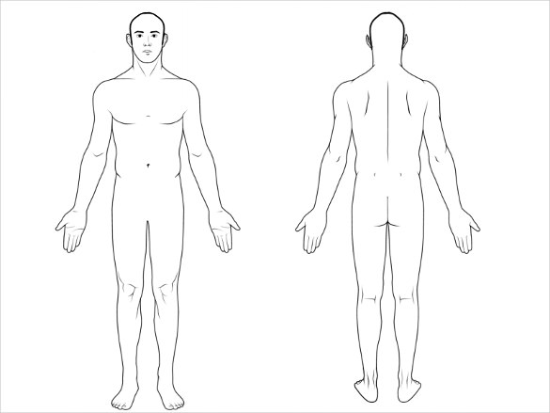

**Please indicate on this diagram any areas of concern:**

**Physical History:**

Have you had any impacts or falls that you feel may have injured your spine?

Please explain: __________________________________________________________________________________________________

Broken Bones? __________________________________________________________________________________________________

Surgeries? _______________________________________________________________________________________________________

Are you active in any particular sports? ______________________________________________________________________

Do you exercise? DAILY / 2-3x PER WEEK / 4-5x PER WEEK / MONTHLY / NEVER

Have you ever been in a vehicular collision? (Please list date(s) and severity):

Have you ever had Physiotherapy? YES / NO Type/Area of injury? ______________________________________

Do you have a Naturopath? YES / NO Name, Date of last visit: ___________________________________________

Are you currently taking and prescription OR over-the-counter medication?

(Please list names, frequency of use, condition taken for):

Are you currently taking any herbs, nutritional supplements or natural remedies? Describe:

____________________________________________________________________________________________________________________

Daily water intake: _____________________ Do you smoke? Y / N If yes, how much? _______________________

Have you ever been on any elimination diets for food intolerance (ex. Gluten-free)? Y / N

Please CIRCLE any conditions you currently suffer from. Please UNDERLINE any past conditions.

Crohn’s Cancer (Type: ______________________) Fibromyalgia Ankylosing Spondylitis

Diabetes Rheumatoid Arthritis Colitis Osteoarthritis Polio Heart Disease

HIV / AIDS Hepatitis Lupus Shingles Scoliosis Gout

Depression Loss of Sleep Osteoporosis

**Please indicate any family history conditions and previous chiropractic care:**

(Ex. Cancer, Diabetes, Heart Problems, Connective Tissue Disorder, Arthritis, Back Pain)

Father: ___________________________________________________________________________________________________________

Mother: __________________________________________________________________________________________________________

Brother(s): ______________________________________________________________________________________________________

Sister(s): _________________________________________________________________________________________________________

Have you ever received spinal adjustments by a Doctor of Chiropractic? YES / NO

If YES: For how long were you receiving adjustments? _____________________________________________________

Doctor’s Name: _____________________________________________ Date of Last Visit:________________________________

If you stopped, why did you stop going? ______________________________________________________________________

**Please check (✓) any conditions that have occurred in the past 6 months. Please underline any symptoms that were a problem in the past 2 years.**

HEAD:

* Headache
* Migraine
* Head feels heavy
* Loss of memory
* Fainting
* Blurred vision
* Light sensitivity
* Dizziness
* Pain in ears
* Ringing in ears
* Loss of balance
* Loss of taste
* Loss of hearing

NECK:

* Pain with movement
* Pain with turning
* Pain looking up
* Pain looking down
* Pinched nerve
* Neck feels out of place
* Muscle spasms
* Grinding or popping
* Arthritis

SHOULDERS:

* Pain in joints (LEFT / RIGHT)
* Pain across shoulders
* Unable to raise arm above shoulder
* Unable to raise arm overhead
* Rotator cuff tear
* Muscle spasms
* Pinched nerve
* Tension in shoulders

MID BACK:

* Pain between shoulder blades
* Sharp/stabbing pain
* Dull ache
* Muscle spasms
* Kidney area pain

ARMS AND HANDS:

* Pain in hands (LEFT / RIGHT)
* Pain in elbows (LEFT / RIGHT)
* Numbness
* Tingling
* Hands cold
* Loss of grip strength
* Swollen joints in fingers
* Arthritis
* Wrist pain

LOW BACK:

* Low back pain (LEFT / RIGHT)
* Upper lumbar pain
* Lower lumbar pain
* Tailbone pain
* Pain with cough/sneeze
* Pain with bowel movement
* Muscle spasm
* Arthritis
* Slipped disc
* Low back feels out of place

HIPS, LEGS AND FEET:

* Pain in buttocks (LEFT / RIGHT)
* Pain in hip joint (LEFT / RIGHT)
* Pain down leg (LEFT / RIGHT)
* Knee pain (LEFT / RIGHT)
* Legs cramps
* Foot cramps
* Pins/needles sensation
* Numbness
* Swelling in legs/feet

CHEST:

* Chest pain
* Breast pain
* Shortness of breath
* Rib pain
* Irregular heartbeat

ABDOMEN:

* Nausea
* Vomiting
* Constipation
* Diarrhea
* Hemorrhoids
* Heartburn
* Poor digestion
* Gallbladder

